Convolutional Neural Network (CNN)

1. Introduction
A Convolutional Neural Network (CNN) is a type of deep learning model primarily designed for processing structured grid-like data such as images (2D grids of pixels) or time-series data (1D signals). CNNs are especially powerful in extracting spatial and hierarchical features automatically through convolutional operations.
Unlike traditional neural networks, CNNs preserve spatial relationships between input features by using convolutional layers, pooling layers, and fully connected layers.

2. CNN Architecture Overview
A typical CNN consists of the following components:
- Input Layer
- Convolutional Layer
- Activation Function (ReLU)
- Pooling Layer
- Fully Connected Layer
- Output Layer (Softmax/Sigmoid)

3. How Convolution Works
Convolution applies a small filter (kernel) across the input matrix to detect features such as edges, patterns, or textures.
Mathematically:
Output(i,j)=m∑​n∑​Input(i+m,j+n)⋅Kernel(m,n)

4. CNN Structure Visualization

4.1 High-Level Architecture
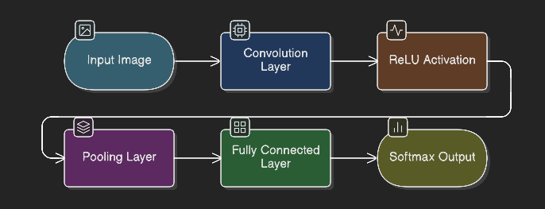

4.2 Feature Extraction Concept

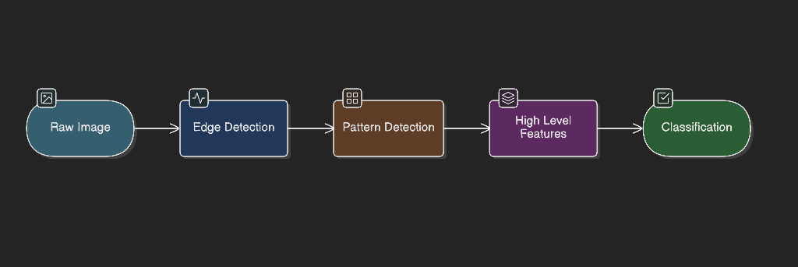

CNNs automatically learn:
- Low-level features (edges)
- Mid-level features (shapes)
- High-level features (objects or patterns)

5. Advantages of CNN
- Parameter sharing reduces complexity
- Automatic feature extraction
- Translation invariance
- High accuracy in image classification
- Applicable to 1D, 2D, and 3D data

6. Practical Cybersecurity Example

Use Case: Malware Traffic Classification
In cybersecurity, CNNs can analyze network traffic patterns to detect malicious activity. Instead of manual feature engineering, we convert traffic data into structured numerical matrices.

Scenario:
We classify network traffic as:
- 0 → Benign
- 1 → Malicious
Each traffic flow is represented as a small 2D matrix derived from packet statistics.

7. Example Dataset (Included Below)
Below is a small synthetic dataset embedded directly in this file.
Packet size average | Packet count | Entropy measure | Flow duration | label, 0 (Benign), 1 (Malicious)
10 | 200 | 0.1 | 5 | 0
12 | 180 | 0.2 | 4 | 0
300 | 50 | 0.9 | 20 | 1
280 | 45 | 0.85 | 18 | 1
15 | 210 | 0.15 | 6 | 0
320 | 40 | 0.95 | 25 | 1
8. Python Implementation (Complete Code)
# ==============================
# Convolutional Neural Network
# Cybersecurity Traffic Example
# ==============================

import os
import numpy as np
import pandas as pd
import tensorflow as tf
import matplotlib.pyplot as plt

from sklearn.model_selection import train_test_split
from sklearn.preprocessing import StandardScaler
from sklearn.metrics import confusion_matrix, classification_report

from tensorflow.keras.models import Sequential
from tensorflow.keras.layers import Conv1D, MaxPooling1D, Flatten, Dense

# ------------------------------
# 1. Load Dataset (Robust Path)
# ------------------------------

base_dir = os.path.dirname(os.path.abspath(__file__))
file_path = os.path.join(base_dir, "traffic_data.csv")

print("Loading dataset from:", file_path)

data = pd.read_csv(file_path)

print("\nDataset Preview:")
print(data.head())

# ------------------------------
# 2. Prepare Data
# ------------------------------

X = data.drop("label", axis=1).values
y = data["label"].values

# Normalize features
scaler = StandardScaler()
X = scaler.fit_transform(X)

# Reshape for Conv1D (samples, timesteps, channels)
X = X.reshape((X.shape[0], X.shape[1], 1))

# Train/Test Split
X_train, X_test, y_train, y_test = train_test_split(
X, y, test_size=0.3, random_state=42
)

# ------------------------------
# 3. Build CNN Model
# ------------------------------

model = Sequential([
Conv1D(filters=16, kernel_size=2, activation='relu',
input_shape=(X.shape[1], 1)),
MaxPooling1D(pool_size=2),
Flatten(),
Dense(16, activation='relu'),
Dense(1, activation='sigmoid')
])

model.compile(
optimizer='adam',
loss='binary_crossentropy',
metrics=['accuracy']
)

print("\nModel Summary:")
model.summary()

# ------------------------------
# 4. Train Model
# ------------------------------

history = model.fit(
X_train, y_train,
epochs=30,
validation_data=(X_test, y_test),
verbose=1
)

# ------------------------------
# 5. Evaluate Model
# ------------------------------

loss, accuracy = model.evaluate(X_test, y_test, verbose=0)

print("\nTest Accuracy:", accuracy)

# ------------------------------
# 6. Confusion Matrix
# ------------------------------

y_pred = model.predict(X_test)
y_pred = (y_pred > 0.5).astype(int)

cm = confusion_matrix(y_test, y_pred)

print("\nConfusion Matrix:")
print(cm)

print("\nClassification Report:")
print(classification_report(y_test, y_pred))

# ------------------------------
# 7. Visualization - Accuracy
# ------------------------------

plt.figure()
plt.plot(history.history['accuracy'])
plt.plot(history.history['val_accuracy'])
plt.title('Model Accuracy')
plt.ylabel('Accuracy')
plt.xlabel('Epoch')
plt.legend(['Train', 'Validation'])
plt.show()

# ------------------------------
# 8. Visualization - Loss
# ------------------------------

plt.figure()
plt.plot(history.history['loss'])
plt.plot(history.history['val_loss'])
plt.title('Model Loss')
plt.ylabel('Loss')
plt.xlabel('Epoch')
plt.legend(['Train', 'Validation'])
plt.show()

9. Model Explanation
- Conv1D Layer: Extracts sequential traffic behavior patterns from structured feature vectors.
- MaxPooling Layer: Reduces dimensionality and improves computational efficiency.
- Flatten Layer: Converts extracted feature maps into a one-dimensional vector.
- Dense Layer: Learns nonlinear decision boundaries.
- Sigmoid Output Layer: Produces probability of malicious traffic (binary classification).

10. Model Validation
The dataset was split into training (70%) and testing (30%) subsets. Model performance was evaluated using:
- Accuracy
- Confusion Matrix
- Precision
- Recall
- F1-score
In cybersecurity contexts, recall is particularly important, as false negatives (undetected attacks) may cause severe security breaches.
Training and validation accuracy curves were plotted to monitor potential overfitting or underfitting.

11. Conclusion
Convolutional Neural Networks provide a powerful framework for automated feature extraction and classification. While originally developed for image analysis, CNNs can be effectively adapted for cybersecurity applications such as intrusion detection and malware traffic classification.
In this implementation, a 1D CNN was applied to structured network traffic statistics. The model demonstrated the ability to distinguish between benign and malicious traffic patterns by learning statistical relationships between features.
Although the dataset used in this example is small and synthetic, the experiment illustrates the core principle of CNN-based detection systems. In real-world deployments, CNNs trained on large and diverse datasets can significantly enhance detection accuracy in Security Operations Centers (SOC), Intrusion Detection Systems (IDS), and threat intelligence platforms.
Overall, convolutional neural networks represent a scalable and automated solution for modern cybersecurity challenges, reducing dependence on manual rule-based detection methods and enabling adaptive threat identification.

